**ConsoleVerse Report - Michal Nickel (N1075587)**

**Usability Heuristics**

**Visibility of System Status**

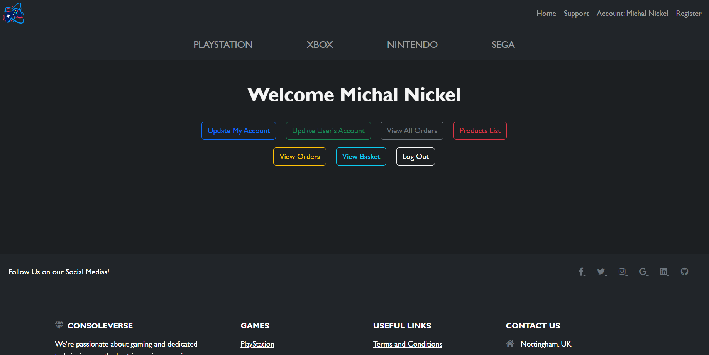

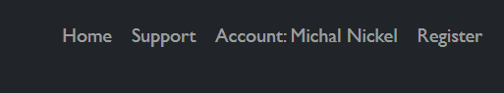

The visibility of system has been taken into consideration when developing the ConsoleVerse website by ensuring that the user is always informed where they are on each page. The layout of the website is simple with the key navigational links on the navbar in the top right corner and the main shopping pages in the centre. I have ensured that they are large, clear and visible on all pages, therefore allowing seamless navigation throughout.

For example, before the user logs into their account, the ‘Sign In’ link in the navbar appears, however when the user logs in to their account, their full name is displayed in the navbar instead. This therefore allows the user, to see who is logged into the account of the website.

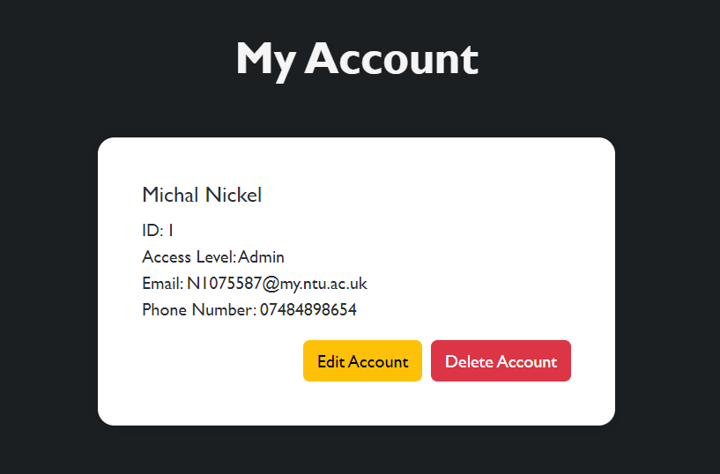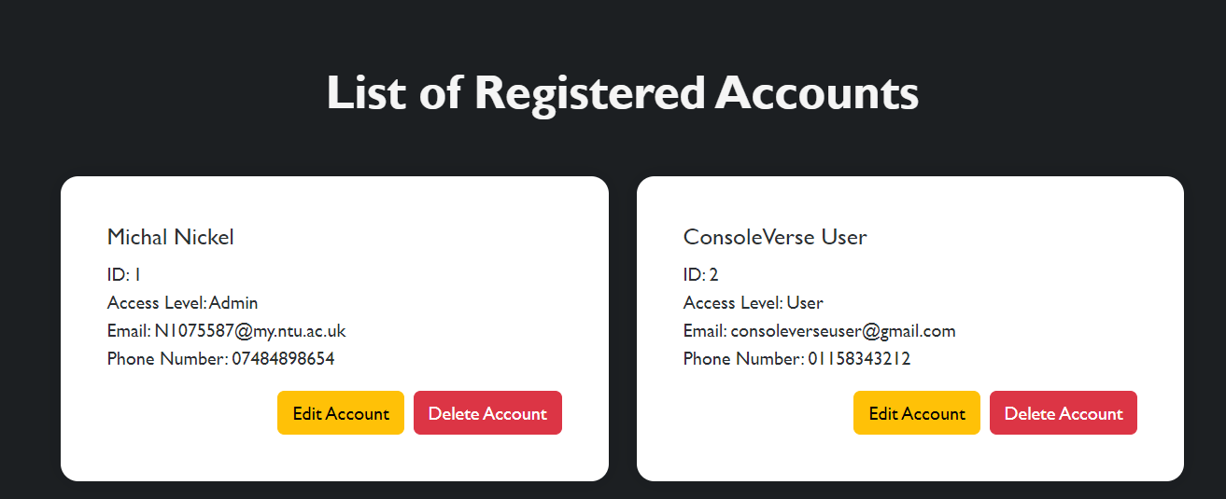

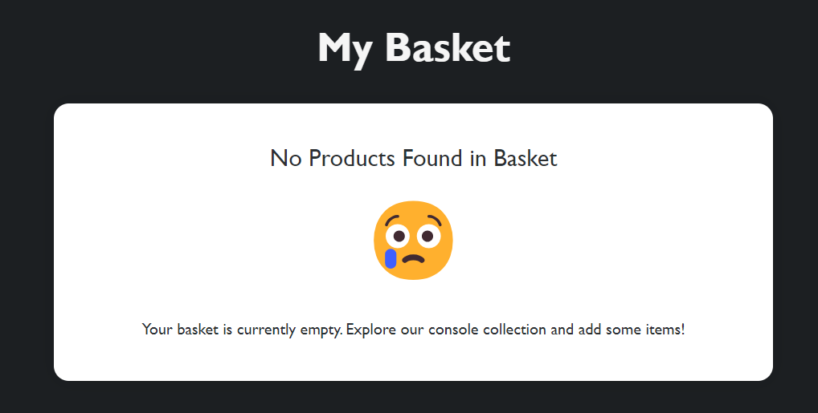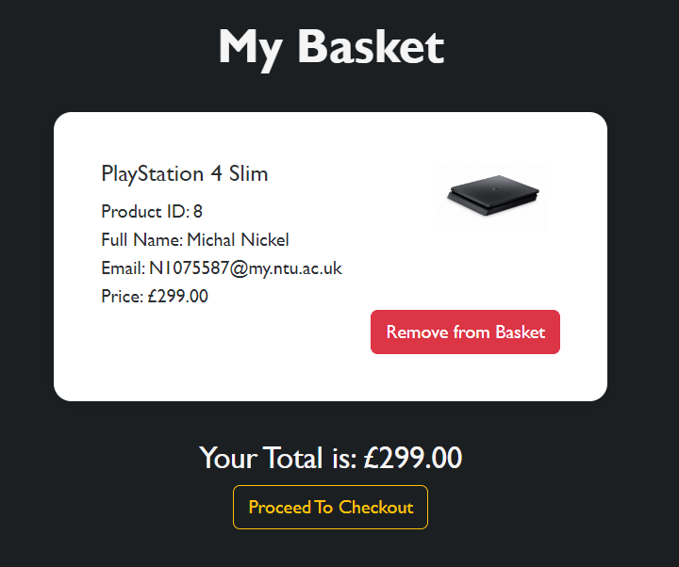

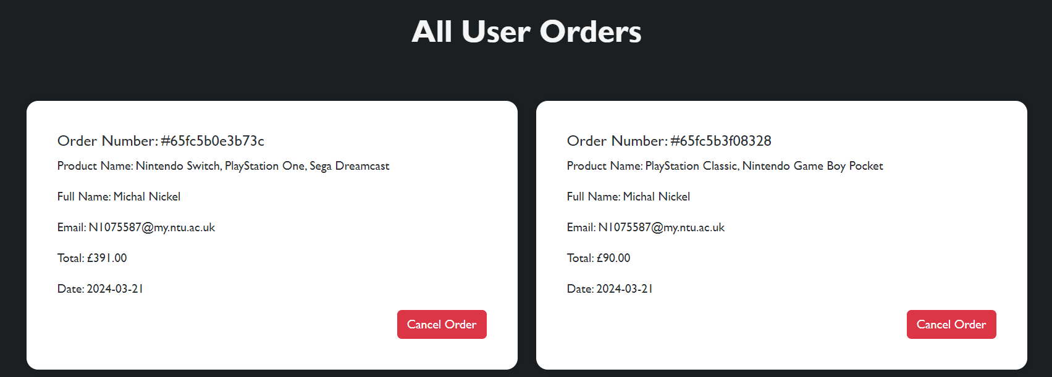

Other visibility of system features such as being able to view your account details, registered accounts, items in your basket or previous orders has given a potential customer more feedback and interactivity on the website. At any time, they can view, update and remove user details on the website without needing the administrator to have access to the database. This will therefore reduce the risk of error or mistakes that could potentially break the database of products, accounts, order history and basket.

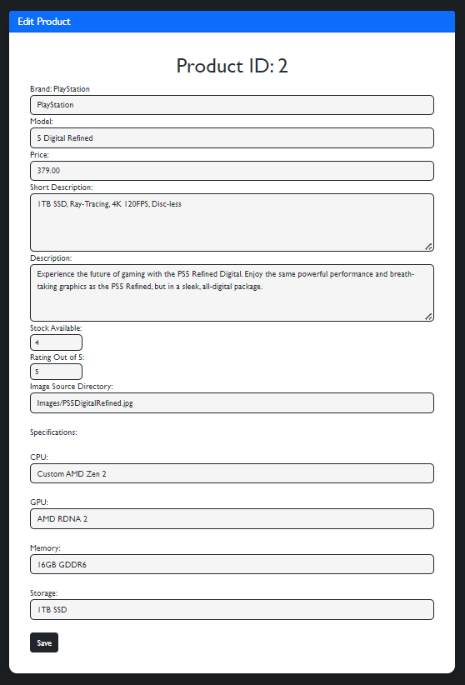

When modifying the details of a product, the administrator can view all the details for the product from the database. This means that they can quickly make changes and adjustments to the everything quickly and efficiently. Using this form, they can update things like the stock available, the descriptions or the price. This form is also useful because it displays the product ID at the top of the form, meaning that the user can easily find the product they are looking for on the website.

**Match with the Real World**

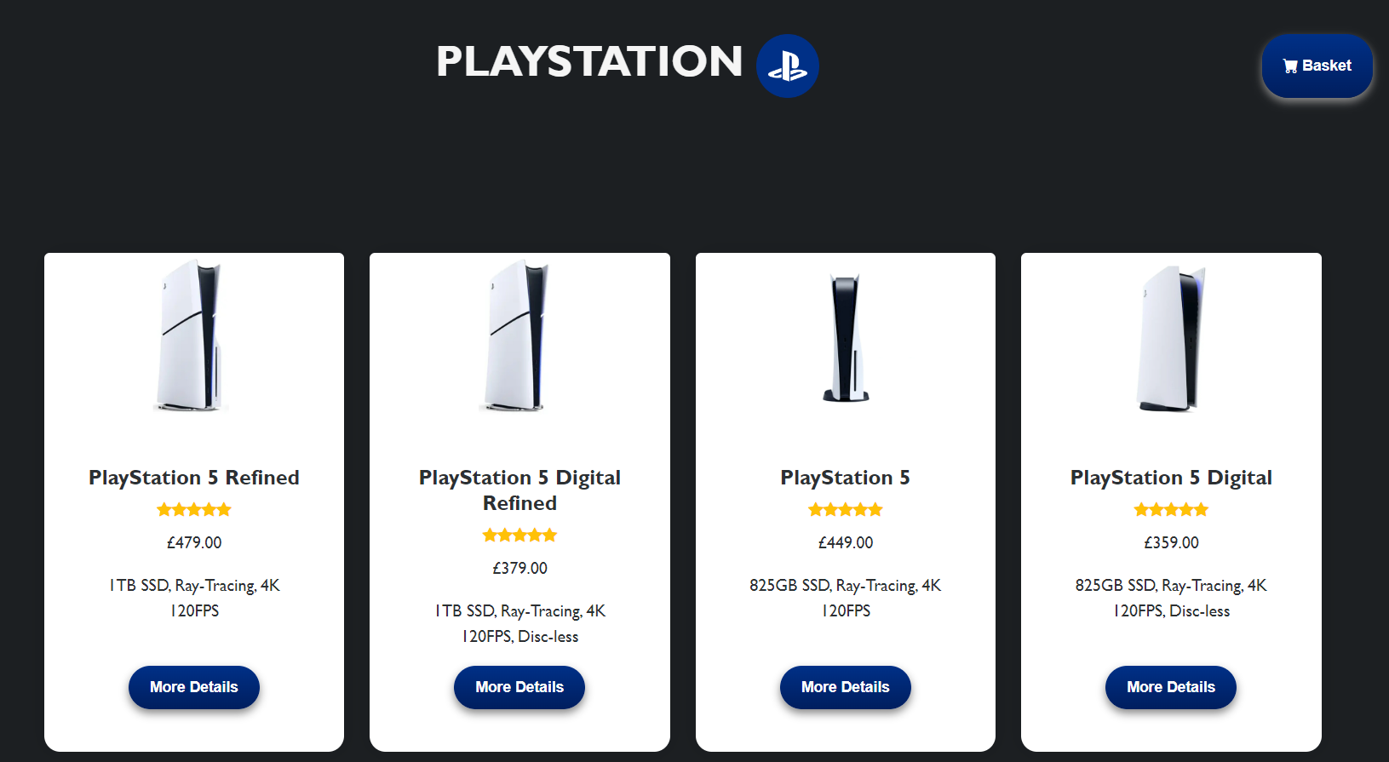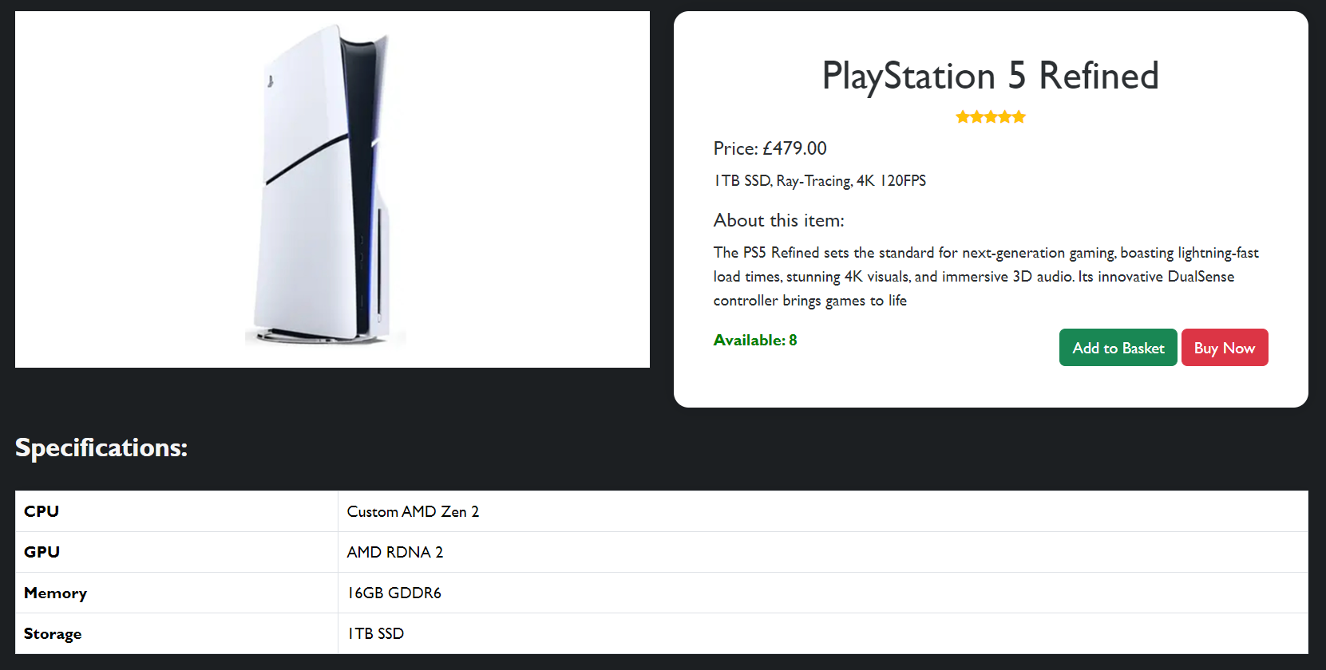

When developing the ConsoleVerse website, it was vital to ensure that everything included on the website matches with the real world. By ensuring that the language used on the website is consistent, it allows for many target audiences to be able to easily shop for consoles and find what they want without needing any technical expertise. For example, on the PlayStation console shopping page you can see the logos, each more details button is colour coded for each console and the basket button also has a small shopping cart icon which matches with the real world. Lastly, each product has their own star rating out of 5 which helps a potential buyer without any technical expertise, the popularity of each console.

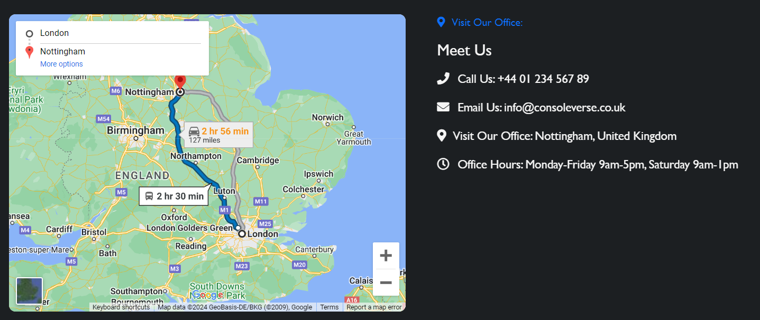

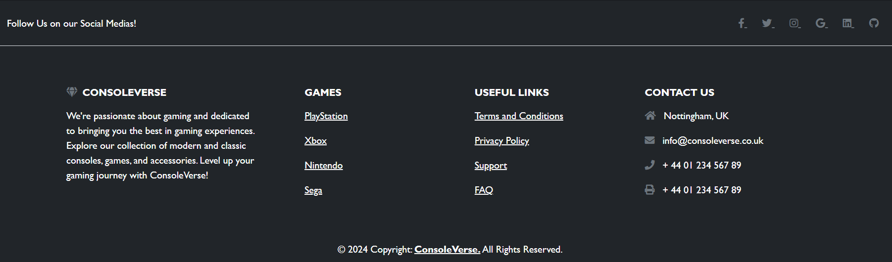

Other examples of the website matching with the real world, is using icons in the support page to help describe the ConsoleVerse company, their mission and contact methods using real world icons that anyone could recognise. The footer has been improved to add further functionality with external hyperlinked pages which a user could find useful. The social media icons are also present here for each platform.

**User Control and Freedom**



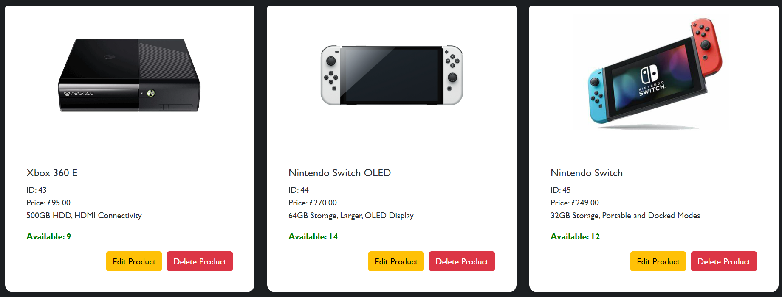

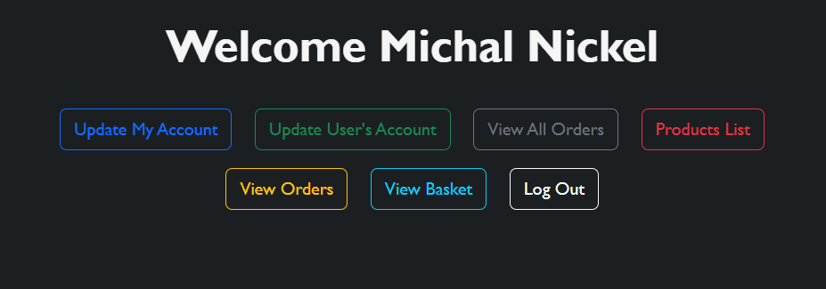

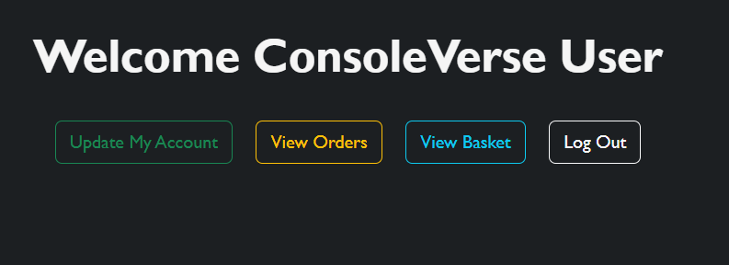

Navigation on a website should be easy and simple, so that if any mistake has been made, it can be undone or any changes to a person’s email address or full name can be rectified. For example, account and products details can be both updated and deleted regularly giving the administrator freedom over how the information is displayed on the ConsoleVerse website. In the images above you can see the functions that both the Administrator and User have when they sign into their account. This provides them the freedom and control to make small adjustments to their account details, cancel or view orders.

**Consistency and Standards**

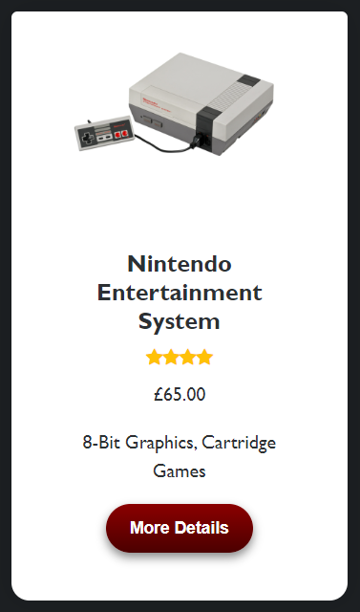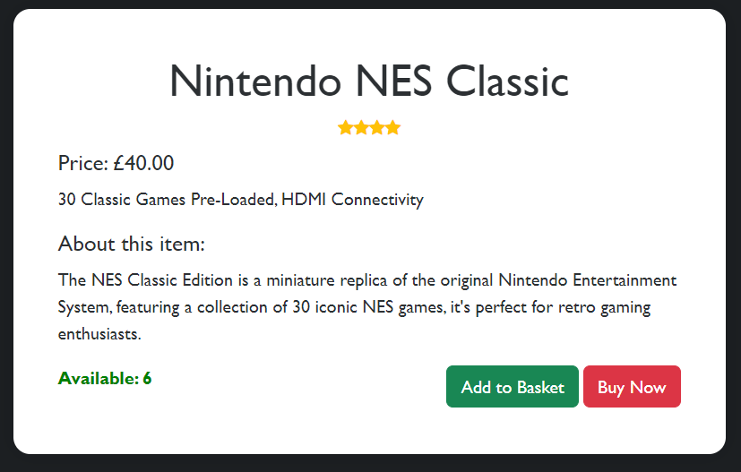

Consistency in the ConsoleVerse website is important to ensure clarity and avoid confusion when buying a product, otherwise you may lose a potential customer because they would go elsewhere. That’s why in this case, I made sure to use simple language and short key words on buttons such as Basket, More Details, Buy Now, Add to Basket. They are colour-coded to help the user know what button to click on next to buy the product or add to basket.

**Error Prevention**

|  |  |
| --- | --- |
|  |  |
|  |

Although not all errors can be prevented, they can be mitigated to reduce the risk of error by using debuggers such as DevTools to help find and fix problems. In my code, I have made sure that all errors display readable feedback to the user to prevent any confusion and guide the user when something does go wrong, rather than have them confused on what to do because you could lose a customer.

**Recognition Rather Than Recall**

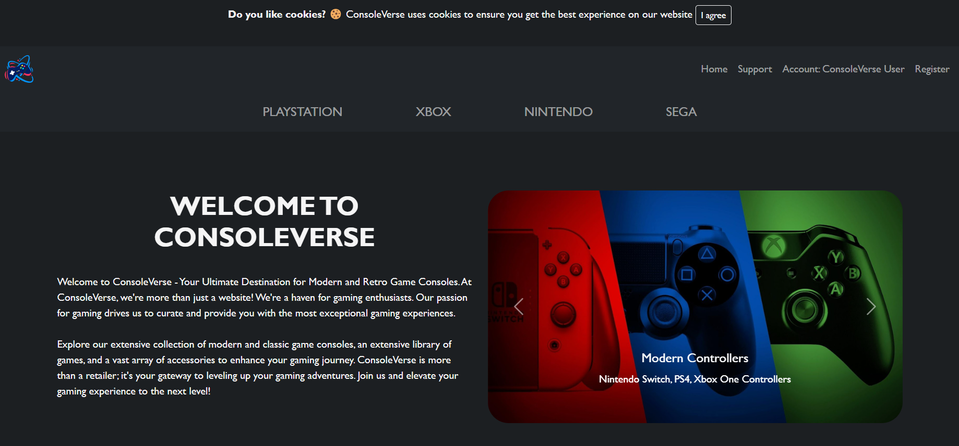



To minimise the load of information on the ConsoleVerse website, I have made sure to include a separate colour scheme to make the website more attractive. The home page is the first page the user sees, so it should hook them to seeing the products they have available. Also, by having different coloured buttons it can help minimise memory load because it helps the buttons stand out and makes them more visible on a dark background.

**Flexibility and Efficiency**



To allow for ease of use, flexibility and efficiency, the website must be designed for users who don’t have technical expertise or knowledge about these consoles. So therefore, the brand names are in the navbar at the top of the screen and then the whole list of products including a short description, the popularity rating and the price. All of these are designed in a card format so each product can be displayed can compared quickly. This provides good flexibility and efficiency as the user only must click on one button to easily find what they want and if the If the user decides to view more information on the product, they can click more details.

**Aesthetic and Minimalist Design**





When shopping for a product, you wish to see everything you want right away. All users must decide on what they want to buy, based on the price, the rating and the description, which is why I decided to include card formats because they are neat and aesthetically pleasing. Also, the user is provided with key information on what they want to buy, without being overwhelmed within the matter of seconds. On the home page, there is a lot more content with slideshows, recent news and some text, however, this has been made minimalistic through the alternating image design and varying the delivery of content to the user, small amounts of text and using bullet points where possible to make it more readable and presentable.

**Error Recover**

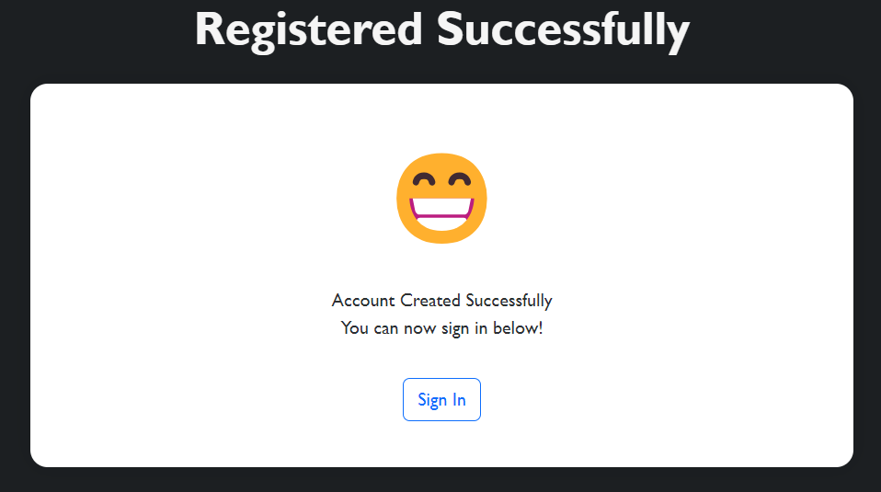

To prevent errors from occurring on the website, I have made sure to include validation on all my forms and ensured that no spelling errors have been present. Any errors which do occur, I have made sure to provide a clear explanation and potential solution to the problem because complicated errors which less tech-savvy users may not understand can often result in frustration and a loss in customers. For example, on the basket and registration successful pages, if an error has occurred or no products have been found in basket, it does not give you an error code. Instead, it provides you valuable feedback and tells you that no products have been found in basket or that their registration has been successful, and they can now sign in to their account.

**Help and Documentation**

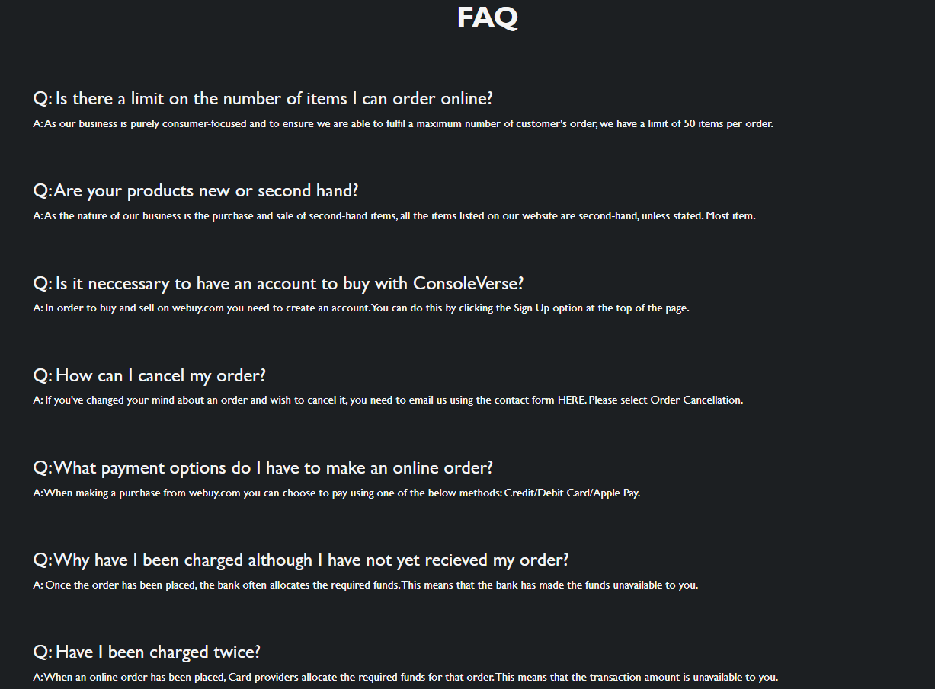



When problems do arise on the website and customers could be facing issues with their accounts or their orders, the ConsoleVerse website has a FAQ (Frequently Asked Questions) page in the footer that contains some questions that customers have had in the past when using the website and provides with a few simple answers/ solutions. This allows for ease of use because the user does not necessarily have to email or call the company to find a solution to common problems. If their issues are not resolved, then they can always go back to the support page where the user has a large variety of contact methods.

**WCAG Principles**

|  |  |
| --- | --- |
|  |  |
|  |

When developing the ConsoleVerse website, I have made sure to consider the WCAG principles to make the website more aesthetically pleasing and providing a variety of interactive components. This includes consistent page organisation and layout to make the website simple to view and operate. The black background helps reduce eye strain compared to a light background especially when there is a lot of information displayed. Consistency throughout the pages and using CSS styling where possible has allowed me to make each button on the console pages to feel unique and consistent to the console colour schemes. For example, PlayStation colours are dark blue, therefore I have made sure that buttons on that page contain the exact same colour scheme.

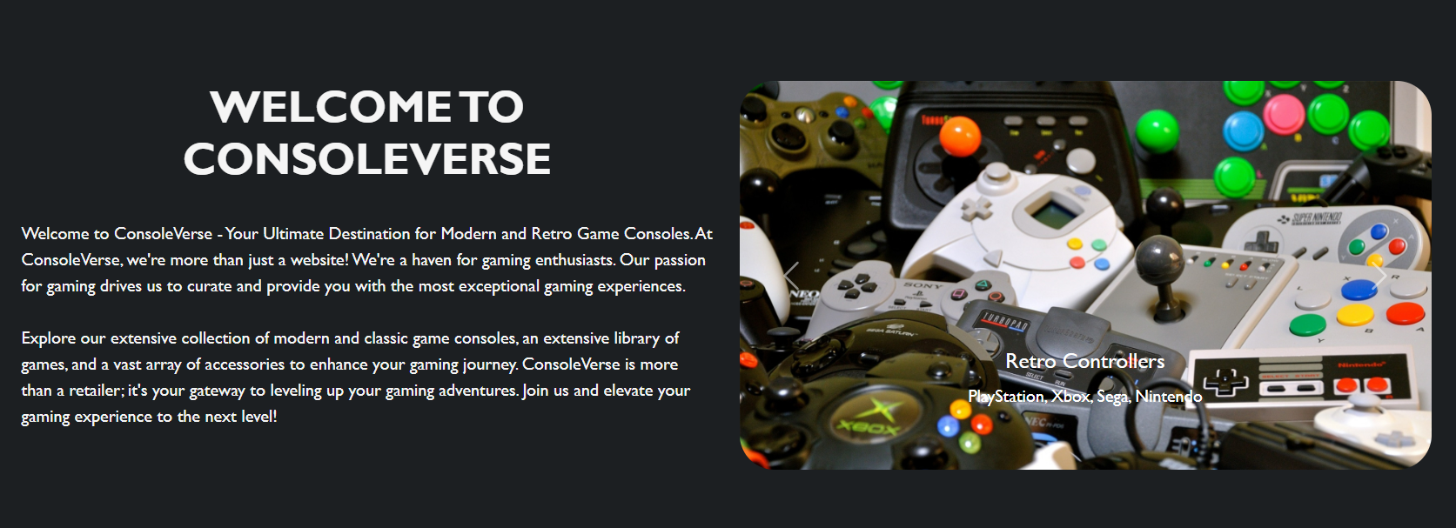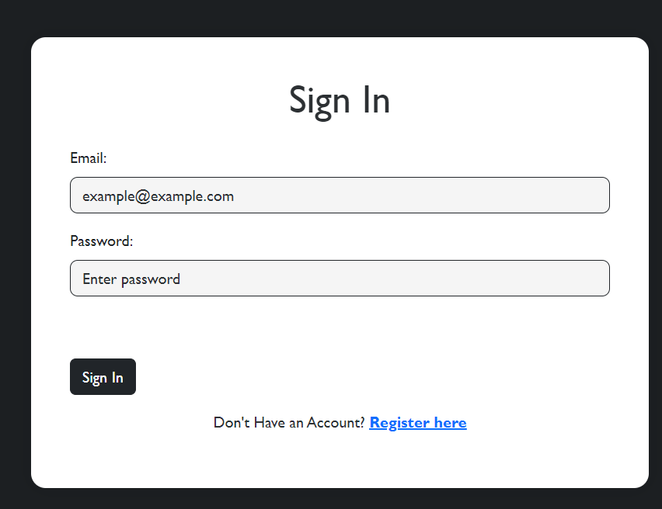



I have also made sure to include hyperlinks, where it makes sense to have them such as the Sign In page because the use may not have an account but instead, they have a small link at the bottom of the page where they can click on if they don’t have an account and they want to register. Same thing with the Register page, there is a link at the bottom which tells the user that if they already have an account, they can Sign In. All the images on the website contains ALT tags, captions and descriptions to make the content more accessible for blind users.

**WCAG Clear Text**



The WCAG Clear Text principles have been considered when developing the ConsoleVerse website such as ensuring that text is visible, clear and readable. Font size throughout the website is 14 points for headings and 12 points for text in paragraphs, this is making the text readable and visible for all users. The dark contrast of the background on the website is suited better for blind, dyslexic and partially slighted user as it puts less strain on the eyes and makes content such as the product cards more visible on screen. The Nielsen Principles tells the developer to avoid using blue on pale blue, or black on yellow, avoid light text on dark background as it makes the website more accessible to all users and their needs, so that everyone can effectively buy consoles using narrator and text-to-speech tools. That is why I have made sure to avoid using red coloured text because colour blind people would not be able to read the text and therefore use the website effectively and efficiently. To make the website more consistent and more readable, all headings, images, paragraphs and columns have lots of breaks to ensure clear spacing. I have also avoided using underlined or italics font styles and used bold highlighting instead because it helps stand out from the rest of the text and being consistent with a sans serif font that is readable. When purchasing a product, the user requires lots of information so it should be both visually appealing, simple and easy to gather information about a product before they buy it.